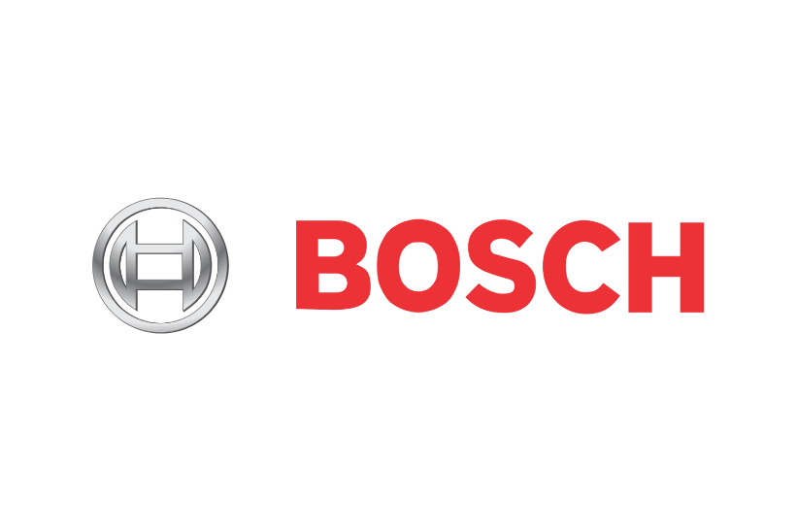

**Team Charter**

R&D - VoteChain Team

April 2, 2018

**Project Coordinator:** Petteri Kaskenpalo

Lam Quang Vu

**Client:** Hoang Le Minh

**Supervisor:** Le Ngoc Son

**Team Members:** Nguyen Trong Tri

Pham Huynh Tri Minh

# Common Goals

|  |  |
| --- | --- |
|  | Aiming to improve Management – Communication – Technical skills is the most essential things for each members. Trying to find what position fits for each person during the project is another important thing to achieve. |

# Core Values

* Respect
* Honesty
* Diversity
* Teamwork
* Professionalism
* Flexibility
* Creativity
* Passion

# Potential obstacles

Several obstacles perhaps hold back our progress. These potential conflicts can be avoided by understanding these obstacles and being proactive about the solutions. These potential contradictions involve:

* Personal: Lovers, pets, other home responsibilities.
* School: Class, clubs, activities, etc.
* Management: Create/ assign Task, roles.

These contradictions could be resolved by applying core values and shared goals.

# Ground rules

Rules:

* Check and put the assigned task in process phase every Monday morning.
* Finish the assigned task on schedule.
* Communicate with other members when need help.
* Contribute in group discussion and work.

Rules are violated:

* Lateness:
  + First time: Warning.
  + Second time: Receive a fine of 10,000 VND.
  + Third time: No credit on the task.
* Not complete task:
  + No credit on the task.
  + Receive a fine of 20,000VND.

# Communication plan

* Daily meeting: 9AM at Bosch.
* Communication Avenues: Face-to-Face / Skype Business.
* Purpose: List all things have been done or problems are facing, what to do on this day.

# Contacts

|  |  |  |
| --- | --- | --- |
| Name | Telephone | Email |
| Pham Huynh Tri Minh | 0937516001 | [1459036@itec.hcmus.edu.vn](mailto:1459036@itec.hcmus.edu.vn) |
| Nguyen Trong Tri | 0983409793 | 1459053@itec.hcmus.edu.vn |